Painkillers linked to heart failure: study

* **30 Sep 2016 at 14:26 1,742 viewed**[**0 comments**](javascript:scrollToAnchor('comment-list');)
* **WRITER:**[**JON FERNQUEST**](http://search.bangkokpost.com/search/result_advanced?category=news&columnistName=Jon+Fernquest)
* **ORIGINAL SOURCE/WRITER:**[**AFP**](http://search.bangkokpost.com/search/result_advanced?category=news&columnistName=AFP+)
* **Level switch:**
  1. [**Advanced**](http://www.bangkokpost.com/learning/learning-from-news/1099048/painkillers-linked-to-heart-failure-study)

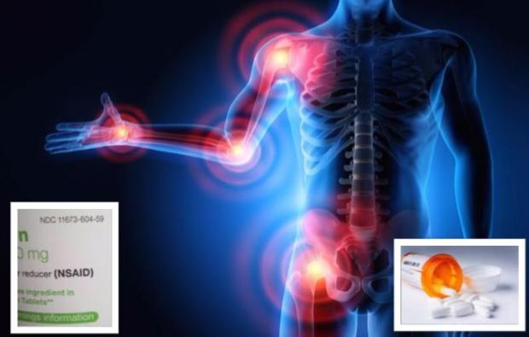

Joint inflammation in the elderly due to medical conditions such as arthritis common reason for taking NSAIDS painkillers but must be careful because these painkillers also associated with heart failure.

Some of the most common drugs to treat pain & inflammation, NSAIDS found to pose risk of heart failure in older people.

HEALTH

Painkillers linked to heart failure: study

28/09/2016   
AFP News Agency

Common **painkillers** have been linked to increased **risk** of heart failure, **according to** a **study** released Thursday.

Non-steroidal **anti** - **inflammatory** drugs (NSAIDs) used to treat **pain** and **inflammation** include such drugs as ibuprofen and naproxen and diclofenac.   
  
Many are among the most **commonly** used drugs to **alleviate** **pain** and **inflammation**, and some were introduced over a **century** ago with **minimal** safety **checks**.   
  
The broad link between the use of NSAIDs and heart failure is **well-established**, but which drugs **pose** the greatest **risk**, and at what **doses**, remains poorly understood.

**THE STUDY**

To get a **clearer** picture, a team of **researchers** led by Giovanni Corrao at the University of Milano-Bicocca combed through the **medical** **records** of nearly 10 million NSAID users in four European countries: Germany, Britain, the Netherlands and Italy.   
  
They **identified** 92,163 hospital **admissions** for heart failure and then **checked** to see which of 27 drugs -- and at what **doses** -- each of them was taking.

**RAISES RISK OF HOSPITAL ADMISSION**  
  
Overall, they found that **current** use of NSAID slightly raised the **risk** of hospital **admission** compared to past use for nine drugs.   
  
These included diclofenac, ibuprofen, indomethacin, ketorolac, naproxen, nimesulide, and piroxicam, along with two COX 2 inhibitors, etoricoxib and rofecoxib.   
  
At very high **doses**, some even doubled the **risk** of hospital **admission**.

**BE CAREFUL TAKING PAINKILLERS**

The BBC article on the **study** includes additional important **precautions** on taking **painkillers** worth remembering (from [here](http://www.bbc.com/news/health-37496348)).

The lowest **dose** **possible** of NSAIDs for the shortest **possible** time is **recommended** by the British Heart Foundation (BHF).

There is no need to worry if **painkillers** are taken only **occasionally** for **aches** and **pains** or sports injuries.

For most people under age 65 the **findings** are said to not be **relevant**, but young people are **warned** against taking the drugs **regularly**.

For the **elderly** above 80 the **findings** are said to be **especially** **relevant**.

The people in the **study** were older and generally in poorer health since they were taking **painkillers**.

Older people **typically** have **joint** problems such as **arthritis**.

NSAIDs, a group of drugs **commonly** taken by patients with **joint** problems, also increase the **risk** of developing heart failure.

For people with **hypertension**, **diabetes** or **kidney** problems, these drugs may also **pose a risk**.

**TAKE PAINKILLERS FOR THE RIGHT REASON**  
  
Over-the-counter **painkillers** should always be used for the right **reasons**.   
  
Ibuprofen is an **anti** - **inflammatory** drug that can be used for damaged muscles with **inflammation**.

For a **headache** where **inflammation** is not an **issue**, it is better to just take an **ordinary** **painkiller** like paracetemol.

**NOT CONTROLLED EXPERIMENT**   
  
The **researchers** emphasised that the **study** was **observational**, meaning that it did not **benefit** from the controlled **conditions** of an **experiment** and thus could not draw **firmconclusions** about **cause** and **effect**.   
  
But the **findings** "offer further **evidence** that the most **frequently** used individual NSAIDs and selective COX2 inhibitors are **associated with** an increased **risk** of hospital **admissions**," they concluded.   
  
The **study** was **published** in BMJ, a leading **medical** **journal**.

**DICLOFENAC NOT RECOMMENDED AT ALL**

"Even a small increase in **cardiovascular** **risk** is a **concern** for **public health**," two Danish heart **experts**, Gunnar Gislason and Christian Torp-Pedersen, wrote in a **comment**, also in BMJ.   
  
For one drug in particular -- diclofenac -- the European Society of Cardiology has **recommended** against its use at any **dose**, they noted.

**BRITISH NHS MOVING AWAY FROM NSAIDS**  
  
Helen Williams, a consultant pharmacist for **cardiovascular** disease at the Royal Pharmaceutical Society in Britain, noted that the country's National Health Service (NHS), the government organization that provides **universal** healthcare **coverage** in the UK, had been "moving away" from the powerful NSAIDs in recent years.   
  
"Reassuringly," she added, "use of the most **commonly** purchased NSAID -- ibuprofen -- was **associated with** a lower overall increased risk" compared to the other medicines, she added in a **comment** released by the Science Media Centre.

http://www.bbc.com/news/health-37496348